Fire ball  
Cross Platform Development

Author: Mara Dusevic

# Change Log

Updates made to the document should be described below.

|  |  |  |  |
| --- | --- | --- | --- |
| Version | Author | Date of change | Description |
| 0.0 | AIE | 31/08/2020 | Initial Template created |
| 0.1 | Mara Dusevic | 4/09/2020 | Added feedback and game overview |
| 0.2 | Mara Dusevic | 7/09/2020 | Added game mechanics |
| 0.3 | Mara Dusevic | 9/09/2020 | Added feedback and edited mechanics |
| 0.4 | Mara Dusevic | 10/09/2020 | Added feedback, assets, edited UI section |
| 0.5 | Mara Dusevic | 11/09/2020 | Added feedback, added controls and fixed errors |
| 0.6 | Mara Dusevic | 18/09/2020 | Edited mechanics, added wireframes to different sections |
| 1.0 | Mara Dusevic | 19/09/2020 | Finished design document and fixed errors |

Contents

Change Log 1

1.0 Development Environment 3

1.1 Game Engine 3

1.2 Source Control 3

1.3 Third-Party Libraries / assets 3

2.0 Game Overview 3

2.1 Genre 3

2.2 Camera Perspective and Movement 3

2.3 Platforms 3

2.4 Technical Goals 3

2.5 Game Objects and Logic 4 - 5

3.0 Controls 5

3.1 Windows / Web 5

3.2 Android / Touch 5

4.0 Mechanics 6

4.1 Hazards 5

4.2 Obstacles 5

5.0 Graphics 6

6.0 Game Flow 7

6.1 ‘Mission’ / ‘Level’ structure 7

6.2 Objectives/Goal 7

7.0 Levels ………………………………………………………………………………………………………………………………………7 - 8

8.0 Interface 8 - 10

8.1 Menu 8 - 9

8.2 UI/HUD 10

9.0 Progress report and feedback Meeting Minutes 11 - 12

Friday 4th September 11

Wednesday 9th September 11

Thursday 10th September 12

Friday 11th September 12

# Development Environment

## Game Engine

Unity 2019.3.6f1

## Source Control

<https://github.com/mdusevic/CPD_UnityExercises>

## Third-Party Libraries / assets

|  |  |  |
| --- | --- | --- |
| **Asset Name**  *License* | **URL** | **Reason for use** |
| **Stylized Lava Texture** *Free –Unity Extension Asset* | <https://assetstore.unity.com/packages/2d/textures-materials/nature/stylized-lava-texture-153161> | Used the texture for the lava at the bottom of each level. |
| **Stylized Rock Texture** *Free –Unity Extension Asset* | <https://assetstore.unity.com/packages/2d/textures-materials/floors/stylize-rock-texture-153452> | Used the texture for the rock wall background of each level. |

# Game Overview

The game called Fire Ball is a 3D platforming game in which the player, as a small ball, faces a variety of levels that contain challenging obstacles and hazards that they must overcome. Each level contains platforms of varying sizes and behaviours that the player must jump to and from to reach the finish line on the last platform.

## Genre

3D Platformer

## Camera Perspective and Movement

There is a fixed camera along the z-axis that will move left, right, up or down depending on the player’s movement.

## Platforms

PC, Web, Android and iOS

## Technical Goals

* Smooth player movement
* Easy to use controls across all platforms
* Multiple levels

## Game Objects and Logic

* **Buttons**

Throughout ‘*Fire Ball*’, there are various buttons to direct players to various levels, pause games, quit the application, etc. This combined with screens, panels and text are used to create menus and pop-ups.

* **Help Boxes**

In the first level of ‘Fire Ball’, to show the player the basics of the game, help boxes appear on screen to tell the player how the pressure plate / moving platform and falling platform systems work. At two points on a particular platform, if the player collides with an invisible wall a dialogue box will appear and tell the player a particular mechanic that they must use ahead. On the dialogue box there is a button which when clicked hides the box away from the player’s view. Alternatively, it can also be hidden from view by pressing the *Enter* key. This was a necessary implementation in order to teach the player.

* **Ball / Player**

The player can move left and right through the selected controls as well as jump. They are used by the player to complete levels. During movement the ball will leave a small ‘fire’ train to indicate to the player their movement which over time disappears.

* **Platforms**

The platforms appear across all levels of ‘Fire Ball’ and are used to help the player navigate each level in order to reach the end goal. They are used by the player to move, access the pressure plates that need to be interacted with, place the finish line, etc.

* **Moving Platforms**

Moving platforms appear across all levels of ‘*Fire Ball*’ and are activated by the pressure plates on its level. They appear static to the player but once activated will move back and forth from two set points, changing direction when colliding with platforms. These were implemented to give the player a challenge when completing levels.

* **Falling Platforms**

Falling Platforms appear across all levels of ‘Fire Ball’ and are activated by the player when they touch the platform. They appear static and are visible to the player with their orange colour. However, once touched by the player they will indicate to the player they will ‘fall’ by turning red. After a set amount of time the platform will delete itself and result in the player to fall if they are still sitting on it. These were implemented to give the players a challenge when completing levels.

* **Pressure Plates**

These objects are placed before the player when moving platforms are ahead and need to be activated in order to be used by the player. They appear static to the player and red to indicate it has not been turned on. Once interacted with by the player rolling over it, it will move downwards and turn green to show it has been turned on. This was a necessary implementation when creating moving platforms in order to slow down the player.

* **Finish Line / Goal**

The finish line appears at the end of all the levels of ‘*Fire Ball*’. The line is coloured green and sits on a platform for the player to roll over or jump into to complete the level. After the finish line the player collides with an invisible wall in which freezes the game and brings up the level complete screen. The finish line was necessary to show the player the end goal of each level and give them a clear objective.

# Controls

## 3.1 Windows / Web

On the windows and web versions of this build the;

* *A* key will move the player in the left direction.
* *D* key will move the player in the right direction.
* *Space* key will make the player jump.
* *Mouse* is used to interact with the menu’s and UI elements.
* *Escape* key will pause the game and show the player the pause menu, pressing again will take the player back to the game.
* *Enter* key is used to quickly hide help boxes appear from view while playing.

## 3.2 Android / iOS / Touch

On the android and iOS versions of this build;

* *Left Tilt* will move the player in the left direction.
* *Right Tilt* will move the player in the right direction.
* *Tapping on the screen* will make the player jump and allow for the player to interact with the menu’s and UI elements.

# Mechanics

* **Jumping**

When the player uses the set button to jump, depending on which direction they are moving they will move up. This jump force remains consistent even with the length of time the jump button is pressed. Once the player is grounded to the platform they can jump again.

* **Moving Platforms**The moving platforms are activated by the pressure plates located before the platforms. Once on they will move between two given points, switching directions on collision.
* **Pressure Plates**When the player rolls on top of the pressure plate, it will indicate to the player it has been pushed by changing its colour from red to green before moving downwards. When activated it will turn on the moving platforms.
* **Falling Platforms**When the player collides with the platform, it will indicate to the player it will fall by changing its colour from orange to red and after a certain amount of time has passed it will delete itself.

## Hazards

There are jump gaps that if fallen into will drop the player into lava and kill them.

## Obstacles

Moving platforms, pressure plates and falling platforms were implemented to add challenge to each level. These require the player to think about timing jumps to reach the end goal.

# Graphics

The game will utilise simple stylised textures for surroundings and the inbuilt material creation within unity. The player will consist of one colour, red, and will emit a trail of white, red, orange as it navigates across each level. The platforms will all be a dark grey colour besides the falling platforms that will be orange and red once interacted with. The pressure plates also work the same way with it being red and green once pushed down by the player. The background wall will use a stylised rock texture and the lava beneath each level with use a stylised lava texture that will move to the left-over time. Overall, the art style of the game is very simple to not overload the player and allow the player to easily determine what they’re looking at.

# Game Flow

## ‘Mission’ / ‘Level’ structure

To deal with memory, each level does not save progress, so if a player exits the level mid-way they will not return to that position when the re-enter that level. The game also loads the necessary screen and unloads the others.

## Objectives/Goal

The objective of the game is to reach the end goal on each level whilst facing multiple obstacles.

1. Levels

**Key**

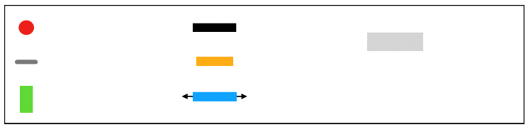

= Ball / Player

= Pressure Plate

= End Goal

= Platform

= Falling Platform

= Moving Platform

= Lava

**Level 1**

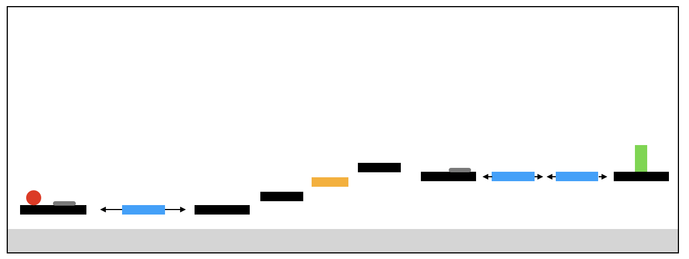

**Level 2**

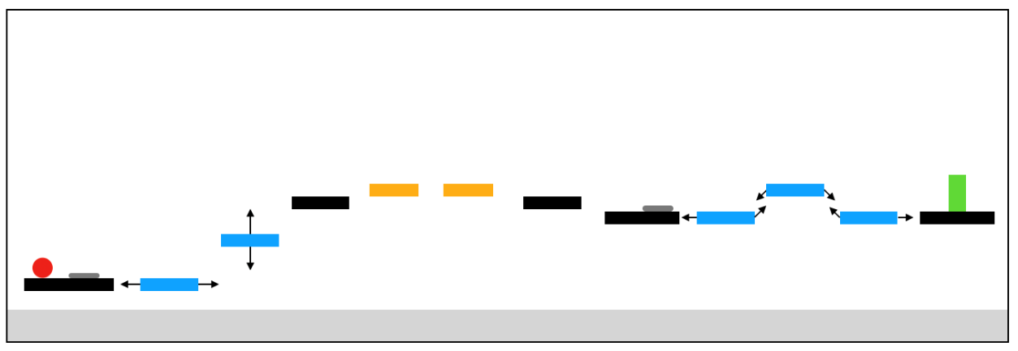

**Level 3**

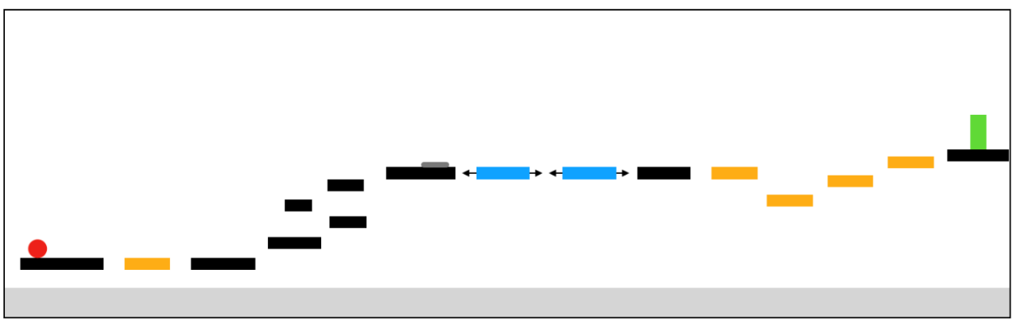

All levels consist of the same challenges how as the player progresses through the levels there is an increase in difficult and length to further challenge them.

# Interface

## Menu

**Main Menu**

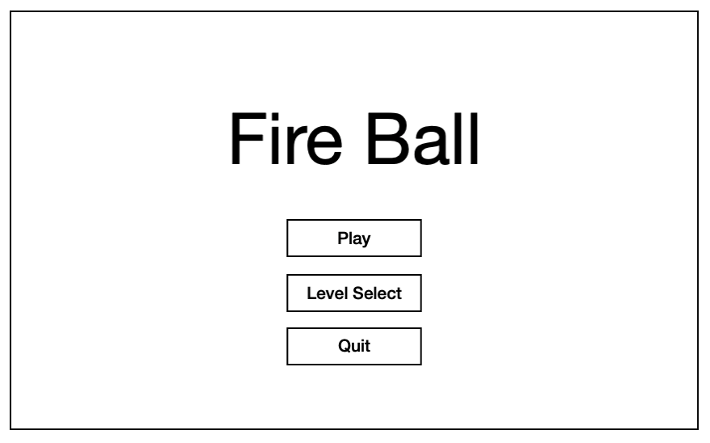

Background is white, menu is separated into own scene

**Title** of the game

**Button**; will take the player to first level

**Button**; will take the player to level select menu

**Button**; will quit the application

**Level Select Menu**

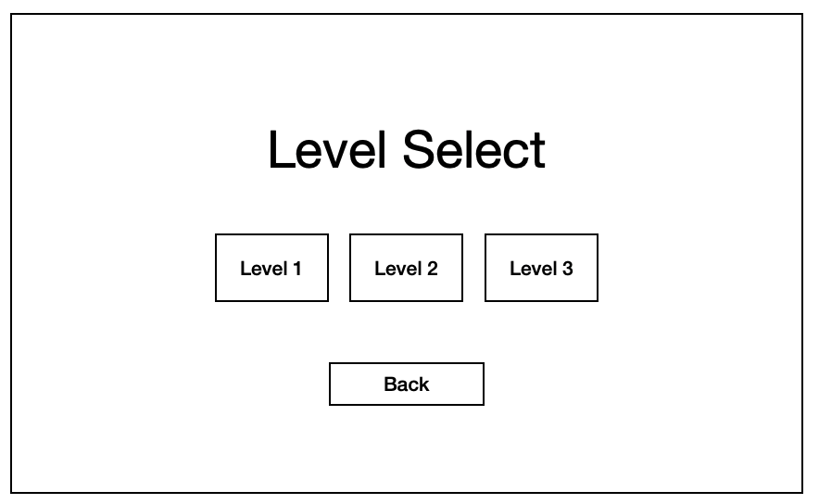

These three **buttons** will take the player to the specified level.

**Button**; will take player back to main menu.

Background is white, menu is separated into own scene.

**Title** of the menu

**Pause Menu**

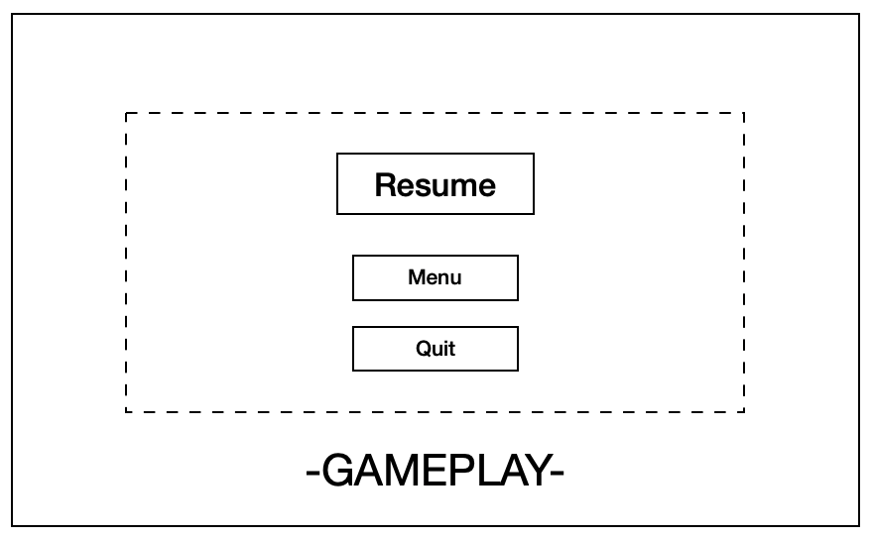

The pause menu appears only when the player is on a level, it darks the screen and freezes the game. On **Windows / Web** you press the *Escape* key to show, pressing again will hide the menu. On **Android / iOS** you must tap an icon in the top left to show the following menu.

**Button**; will hide menu and unfreeze gameplay allowing the player to resume.

**Button**; will take player back to main menu.

**Button**; will quit the application.

**Level Complete Menu**

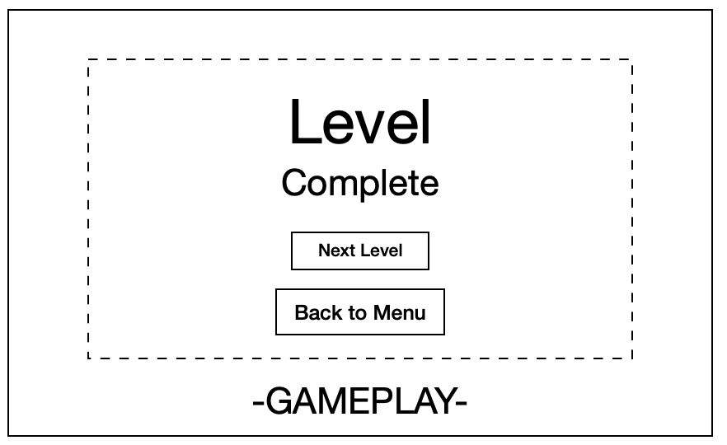

The level complete menu appears only when the player has reached the end goal of the level, it will show a box over the gameplay screen and freeze the game.

**Title** to indicate to the player they have successfully completed the level.

**Button**; will take player to the next level. When player completes the last level, this button is not shown.

**Button**; will take player back to main menu.

**Game Over Menu**

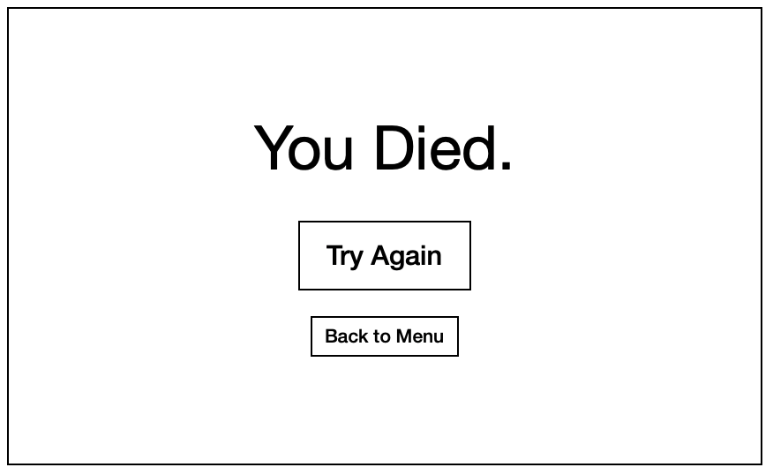

Background is red, game over screen is separated into own scene.

**Title** to indicate to the player they have failed in completing the level.

**Button**; will take the player back to level one.

**Button**; will take the player back to main menu.

## UI/HUD

**Pause Icon**

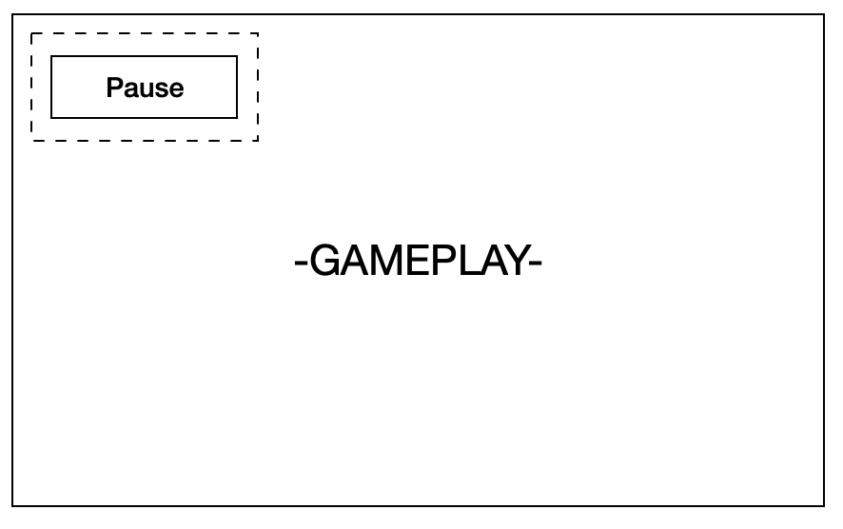

The pause button appears only when the player is on a level and shows the player the pause menu. The button can be activated alternatively via the *Escape* key on **Windows / Web**.

**Button**; will show the pause menu to the player.

**Help Boxes**

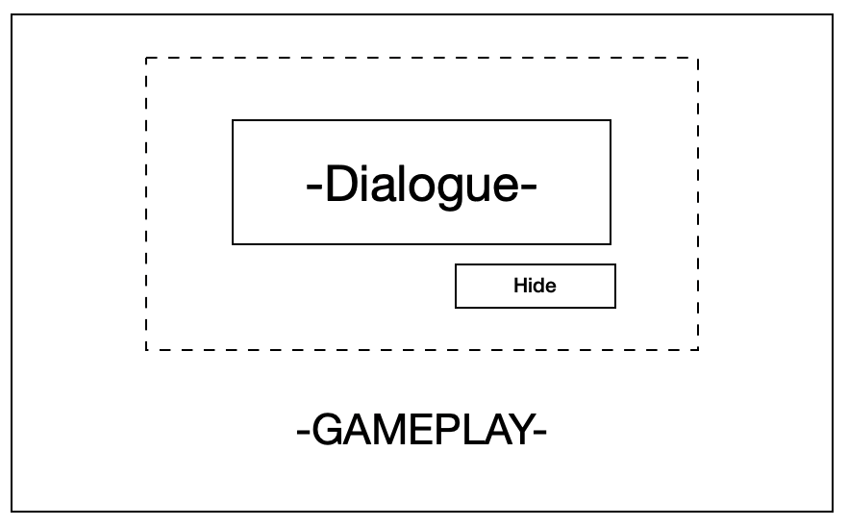

The help boxes appear only when the player is on level one and hits a certain point of the level, it will show a box over the gameplay screen. On **Windows / Web** you can press the *Enter* key to hide the box, or click the hide button. On **Android / iOS** you must tap the button located just below.

This contains **text** that will explain to the player how a certain game mechanic works. The text will change depending on the mechanic.

**Button**; this will hide the help box from player view.

# Progress report and feedback Meeting Minutes

## Friday 4th September

**Describe state of project**

* Main menu and game over scene are implemented
* One basic platform level
* Added windows and web builds

**Feedback from teacher and peers:**

* Fix issues with moving platforms
* Fix player movement
* Needs some menus
* Needs some textures

**Action Items:**

* Attempt to implement the suggestions received from peers
* Fix bugs

## Wednesday 9th September

**Describe state of project**

* Added android build
* Added textures to game
* Started adding touch controls for mobile devices
* Added a new level

**Feedback from teacher and peers:**

* Add more levels
* Fix invisible platform collision issues
* Fix player attachment to platform

**Action Items:**

* Implement suggestions
* Fix bugs

## Thursday 10th September

**Describe state of project**

* Added textures
* Added a new level
* Added an iOS build
* Updated builds for all platforms

**Feedback from teacher and peers:**

* The difficulty as levels progressed was complimented
* Textures received positive feedback

**Action Items:**

* Update the last level
* Add new obstacle

## Friday 11th September

**Describe what has been done since last time**

* Fixed touch controls
* Added another level
* Added level select menu
* Fixed moving platform problems
* Changed pause icon

**Feedback from teacher and peers:**

* The entirety of the game received positive feedback
* UI elements are a bit plain

**Action Items:**

* Attempt to implement the suggestions received from peers
* Fix bugs and issues